SOFTWARE REQUIREMENTS SPECIFICATION (SRS) V2
Automation Exercise
Web Automation Testing Project

Prepared By:
Basil Samouh
Ahmad AlGul
Hamza Belal
Mohammed AlSwesy

Contents
Purpose of the Document 4
1. Project Overview 4
1.1 Hardware and Hosting: 4
1.2 Core Modules Scoped: 4
2. Information Architecture 5
2.1 Login Page & Initial Signup Module 5
2.2 Signup Details Module 6
2.3 Product Page Module 8
2.3.1 Search Engine Integration: 8
2.3.2 Category and Brand sidebar: 9
2.3.3 Product Detail View: 9
2.3.4 Product Review: 10
2.4 Cart Page Module 10
2.4.1 Add to the cart 10
2.4.2 View cart page 11
12
2.5 Checkout Page Module 12
2.5.1 Checkout order items 12
2.5.2 Payment 13

Purpose of the Document
The purpose of this document is to define the software requirements for testing the Automation Exercise web application. This website focuses on simulating a real-world item shop for viewing the product page with customization, seeing the details of any item shop, adding to the cart, and proceeding to checkout and placing the orders. This is not a project plan. It is a guide for system architecture and development, not for phasing, timelines, or deliverables. This document is divided into three sections:
- Project Overview
- Information Architecture

1. Project Overview
This document is intended as a complete guide for Guest and Registered Users (as well as QA automation engineers) in using Automation Exercise. This document is specially designed for non-specialists; specialists may find the document a useful point of reference. By reading this guide, you will learn how to use Automation Exercise through the elements of the graphical user interface and what's behind some of the advanced features—like the dynamic checkout workflows and multi-step registration forms—that are not always obvious at first sight. It will hopefully guide you around some common problems that frequently appear for users of Automation Exercise

1.1 Hardware and Hosting:
Automation Exercise’s servers are hosted at a secure cloud data center provider’s site. Automation Exercise is hosted on two servers: One to host the actual website and web application code, and the other to host the MySQL relational database containing product catalogs, user credentials, and transactional logs.

1.2 Core Modules Scoped:
- Login & Initial Signup Module
- Detailed Account Registration Module
- Product Catalogue & Detail Module
- Shopping Cart Module
- Checkout & Order Placement Module

2. Information Architecture

This section maps the structural dependencies, business rules, and field requirements for the five core modules under scope.

2.1 Login Page & Initial Signup Module
This module handles entry points for both returning users and new visitors.
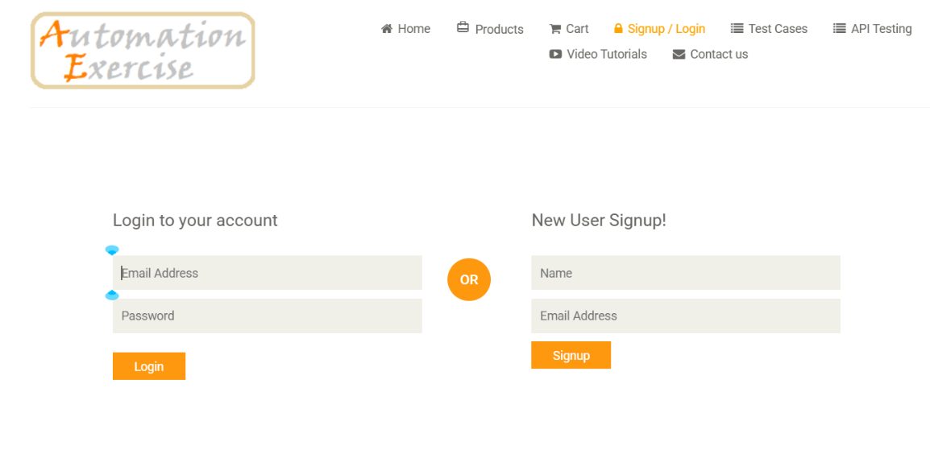

Authentication Rules: Accepts a registered email string and a masked password string. If authentication fails, a validation message must instantly state: "Your email or password is incorrect!"

User Account:
Email | Password
Email solefi8727@okcpress.com | QualityAssurance

2.2 Signup Details Module
Initial Signup Rules:
Collects basic user parameters (Name and Email Address) to instantiate a registration wizard.
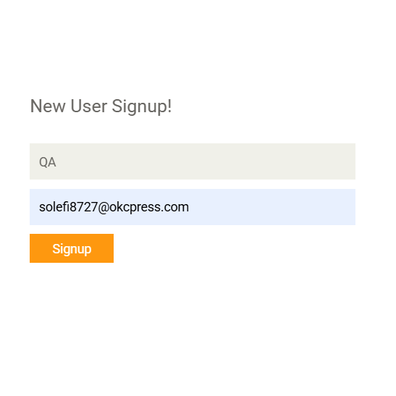

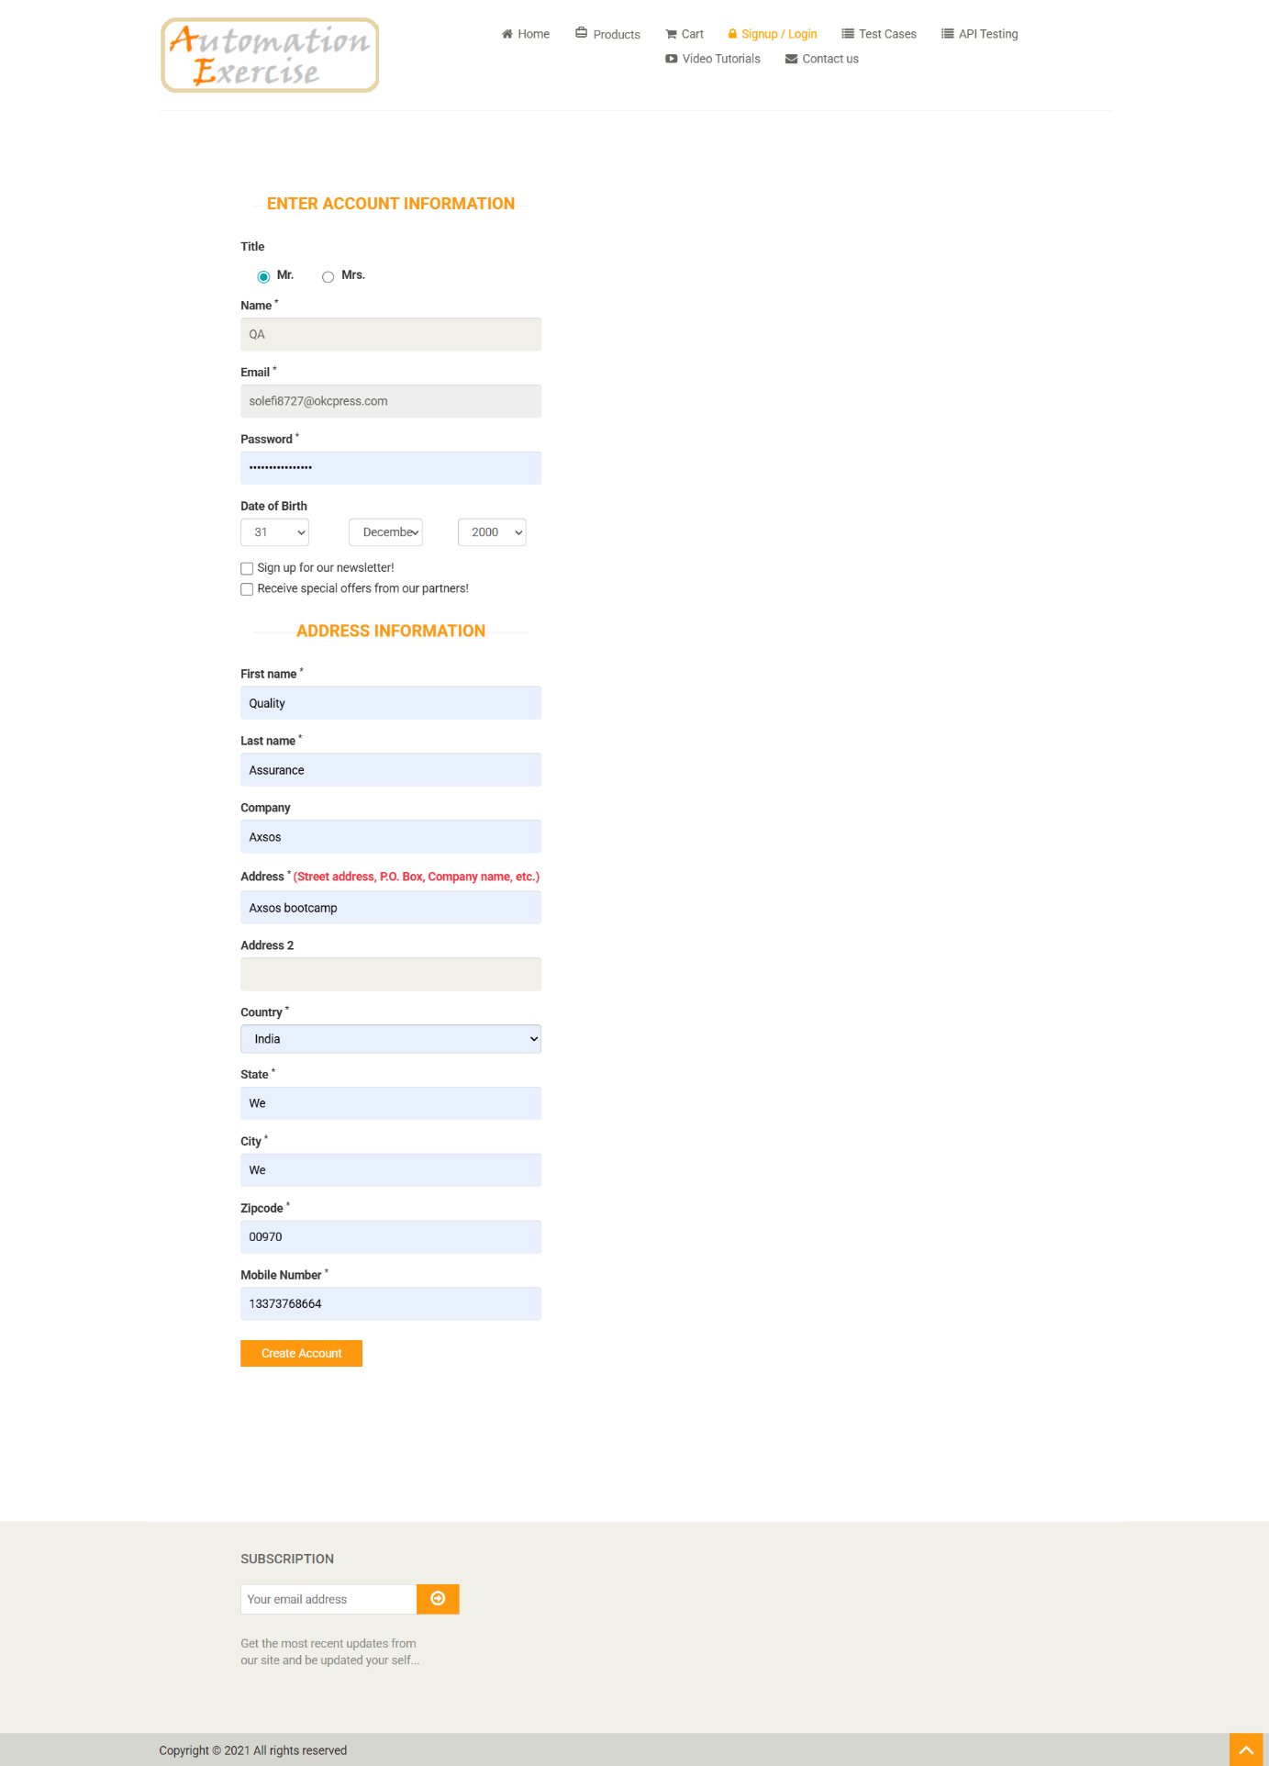
A deep data collection matrix activated only upon successful completion of the initial signup validation flow.

Filling title, password, dob, first name, last name, company, address, country, state, zipcode, mobile phone. After that, click on “Create Account”.

2.3 Product Page Module

Governs catalog displays, individual item deep-dives, and search querying interfaces.

2.3.1 Search Engine Integration:
Processes text queries from the global search input bar. Returns exactly matching or category-relevant item grids.


2.3.2 Category and Brand sidebar:
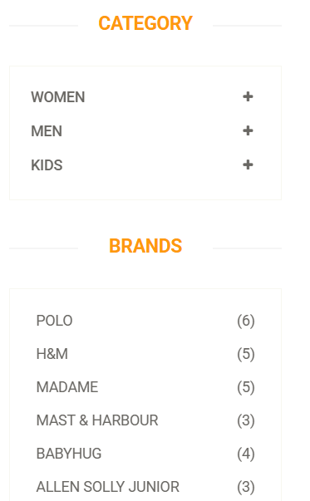
can customize what items are shown in the product page based on what you want, items for men, women, kids or maybe the breand you like

2.3.3 Product Detail View:
Renders item-specific metadata dynamically from the database server, mapping the following specific attributes:
- Product Name & Category Path
- Pricing Label (e.g., Rs. 400)
- Availability Status (In Stock / Out of Stock)
- Condition Tier (New / Used)

- Brand Identity

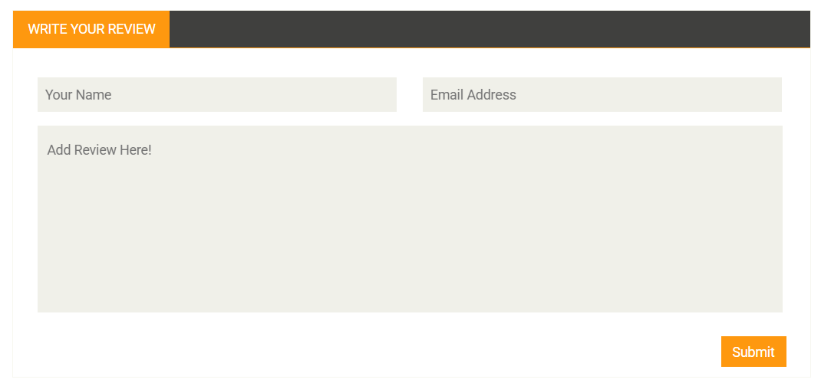
2.3.4 Product Review:

After getting the item from the shop, you can submit your review after filling in your name and email, then write your review message, and submit.

2.4 Cart Page Module
Acts as the central clearing staging area for tracking selected items prior to initiating financial routing.

2.4.1 Add to the cart
You can add them by “View Product.” And inside click on “Add to cart”


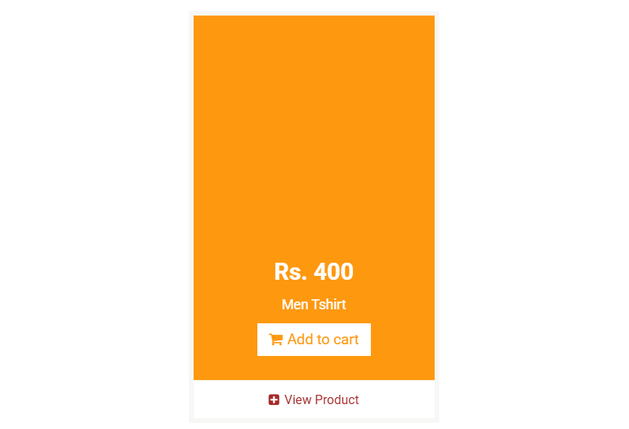
Or by adding from the outside in the product page

2.4.2 View cart page
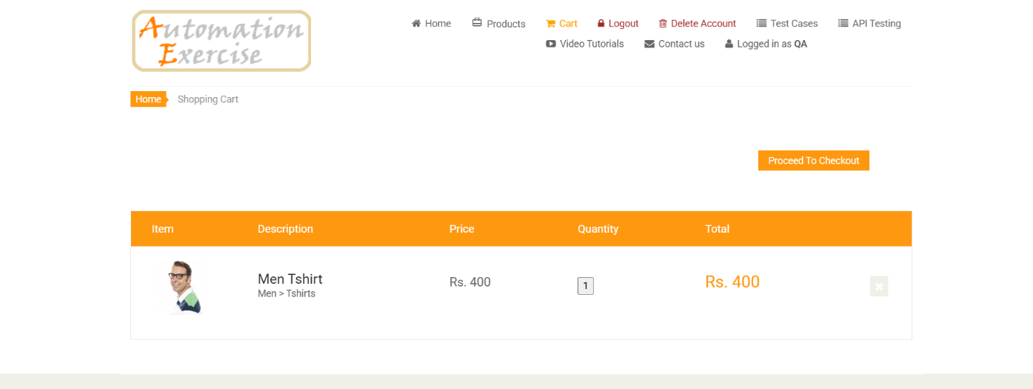
Tabulates items in a structural grid displaying the product image thumbnail, description link, pricing metrics, item quantity counts, and calculated line totals

2.4.2.1 Remove the item
The customer can remove the item from the cart by click on (X) icon.
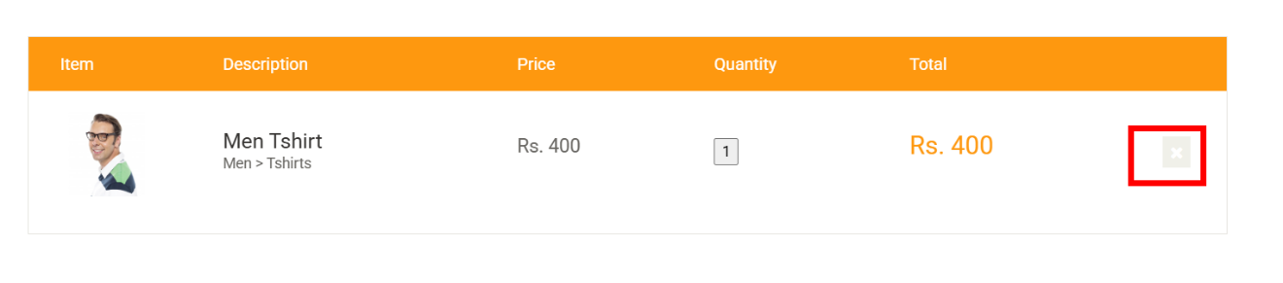

2.5 Checkout Page Module
The structural multi-point verification interface used to review orders prior to final ledger commitments.
You can navigate to checkout after click on “Proceed to checkout”.
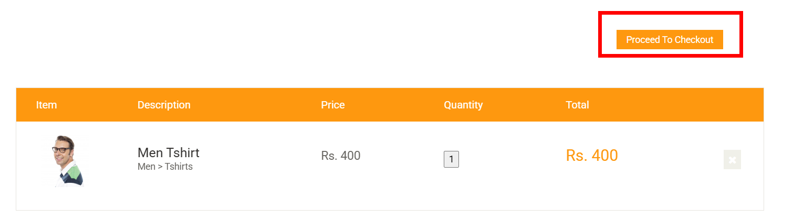

2.5.1 Checkout order items
In this page you can see the items you added to the cart and check all address details, or order details like the item, description, price, quantity, total, and total amount
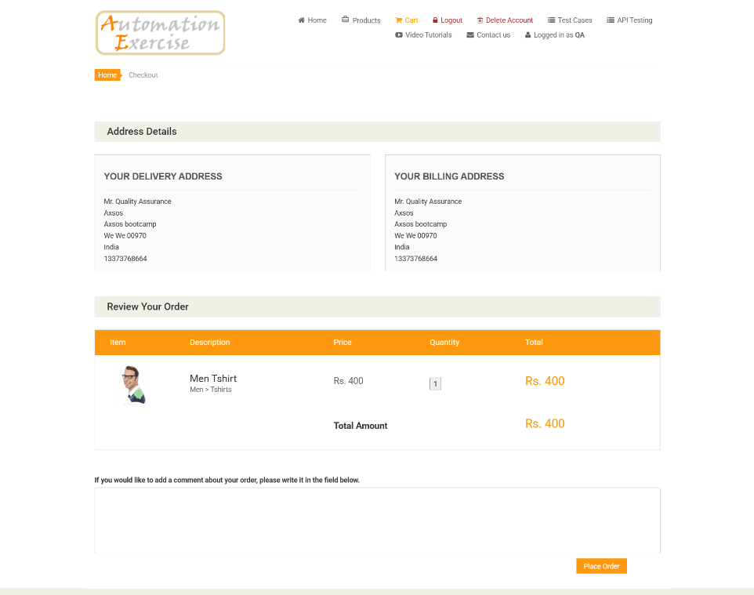

After checking all details, and you are ready to order click on “Place Order”

2.5.2 Payment
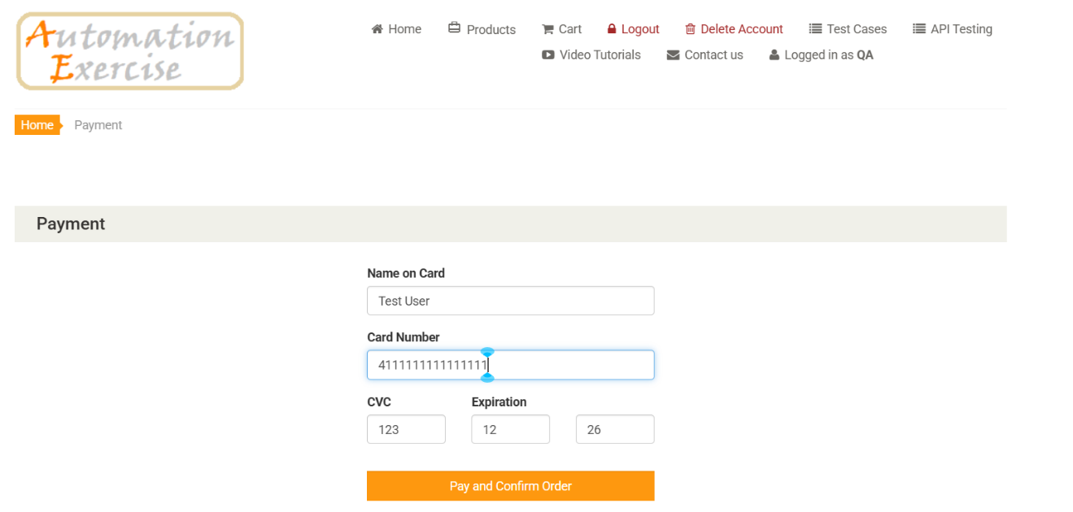
Fill all mandatory fields in Payment page to finish the placing order
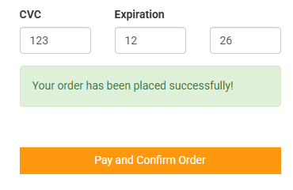
Click on “Pay and Confirm Order”


And you can download the Invoice or continue to order another item

